

CSE 523 Machine Learning

Progress Report - 4

Section 1

Date of Submission: 2nd March 2022

Group Name: **Bug Smashers**

Group Details

| Roll No | Name |
| --- | --- |
| AU1940028 | Moksh Doshi |
| AU1940120 | Jaimik Patel |
| AU1940130 | Nandish Patel |
| AU1940164 | Jenil Bagadiya |

2022 Winter Semester

# Tasks Performed this week

* Normalized the data set using minimum and maximum values
* Implemented KNN algorithm using external library
* Implemented KNN from scratch

# Outcomes of the tasks performed

* Achieved a maximum accuracy of 72.5% for KNN model

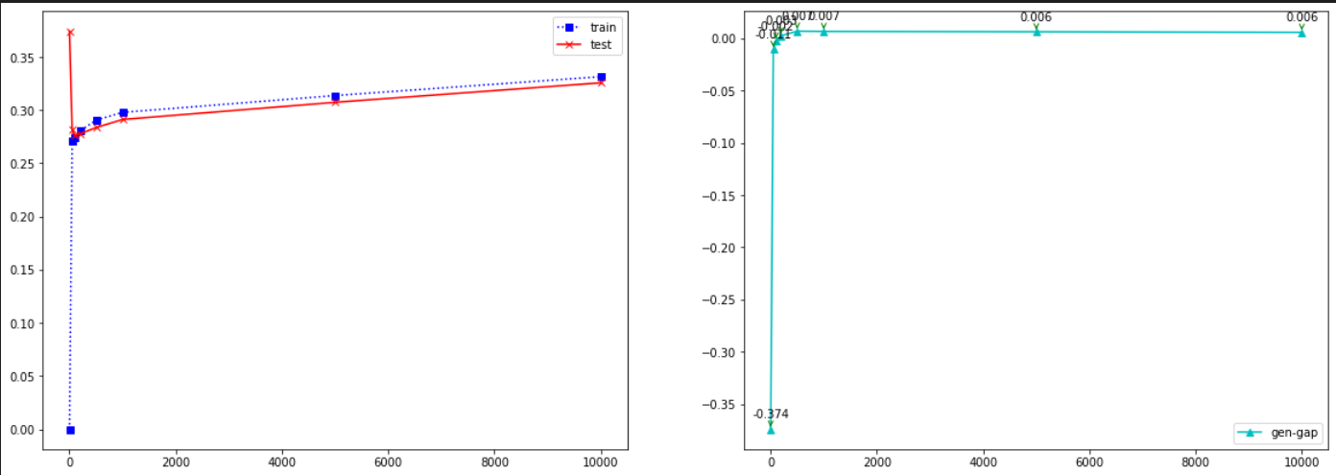

* The left graph shows the training and testing errors for k ranging 1, 51,101 …. 10001. Minimum error is achieved around k=100-200 range
* The right graph shows the generalization gap between the training and test datasets. Minimum gap is achieved around k=100-200 range

# Tasks to be performed in the upcoming week

* + Implement standardized performance metrics that can used for all of models
  + Optimize the performance of KNN from scratch model to work with full dataset
  + Code another classification algorithm - **logistic regression**